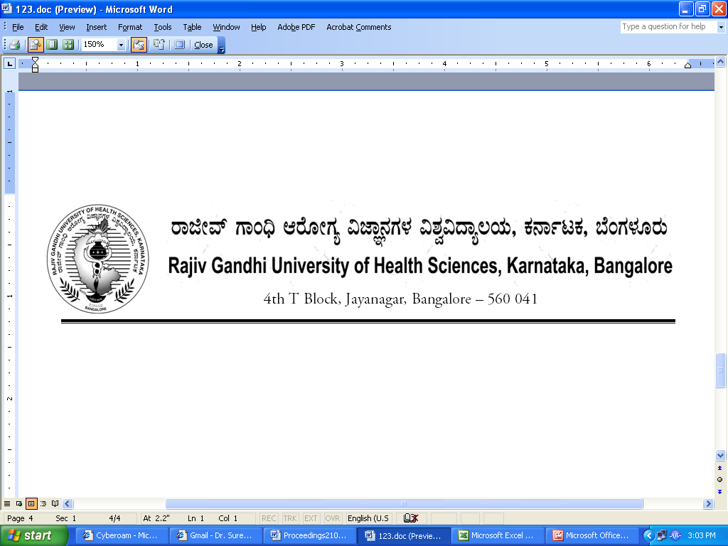
Reg (E)/Exam/Nursing/May - 2018 Date: 28/05/2018

CORRIGENDUM

Sub: | Conduct of B.Sc Nursing (Basic & PB) Course Examination during May -2018
Ref: | This office Notification No. R(E)/UG/Nursing/Pract/May - 2018, Dated: 10/05/2018.

* * * * *

In continuation of this office Notification cited above, the following practical examination dates of B.Sc Nursing (Basic & PB) May 2018 are rescheduled as shown below
SL NO | Scheduled Dates | Rescheduled Dates
1 | 17.05.2018 to 29.05.2018 | 17.05.2018 to 31.05.2018

The Principals are requested to notify this on the Notice Board of their colleges for information prominently

By Order

Sd/-
Dr. M.K.Ramesh
Registrar [Evaluation]
To:

All the Principals of the affiliated colleges for information .

Copy to:

- PA to Vice-Chancellor/Registrar/Registrar(E)/Finance Officer, RGUHS, Bangalore.
- All the Officers of the RGUHS, Bangalore.
- The Computer Department to host in our RGUHS website.
- Guard File.

